***AiTuskDay1__12/3***

1. **All companies work in AI fields**

| **Company** | **Domain** |
| --- | --- |
| [ABM Egypt](http://abmegypt.net/) | NLP, Social Media analytics, Search Engine optimization |
| [Adam.ai](https://adam.ai/) | NLP, machine learning, embedded systems |
| [Advansy ESC](https://www.advansys-esc.com/) | Embedded Software, Big data, IoT |
| [Affectiva](https://www.affectiva.com/) | Machine learning, Deep learning, Computer vision, Speech(new project(s)) |
| [Agolo](https://www.agolo.com/) | NLP, ML, DL |
| [Arqamfc](https://www.arqamfc.com/) | Analytics |
| [Ave labs](https://www.avelabs.com/) | Deep learning, Machine learning techniques, Computer vision, Image Processing and Signal Processing, Control theory & Artificial Intelligence |
| [AvidBeam](https://www.avidbeam.com/) | Machine learning, OCR, Computer vision, DL |
| [Elves](https://www.elvesapp.com/) | Chatbots |
| [Bee Smart Payment Solutions](https://bee.com.eg/en/) | ML, Big Data |
| [Cequens](https://www.cequens.com/) | Predictive models, Machine Learning, Chatbots |
| [Cognitev](https://cognitev.com/) | ML, DL, Recommendation systems, IR (Information Retrieval), NLP (Natural - Language Processing) |
| [Comiot](https://www.com-iot.com/) | Iot, Computer vision, ML |
| [Crowd Analyzer](https://www.crowdanalyzer.com/) | Big data, Machine learning, Social Media Analysis, Arabic in Social Media Analytics |
| [Data Gear BI](http://www.datagearbi.com/) | Data Mining, Business Intelligence(BI) |
| [El menus](https://www.elmenus.com/) | Recommendation systems, NLP |
| [Heuro Labs](http://www.heurolabs.com/) | Artificial Intelligence, Cognitive Computing, Machine Learning, Big Data, Data Fusion and Data Mining |
| [IBM Egypt](https://www.ibm.com/eg-en) | NLP(Watson practice team), ML, DL |
| [Incorta](https://incorta.com/) | Robotics, computer vision |
| [InnoVision Systems](http://www.ivsystems-eg.com/) | Robotics, computer vision |
| [Itworx](http://www.itworx.com/) | Big Data |
| [Knowledge officer](https://knowledgeofficer.com/) | information retrieval and text summarization for articles on the web. Based mainly for many NLP and recommendation systems |
| [Mendel.ai](https://mendel.ai/) | Artificial Intelligence in Medicine, Machine learning, OCR, NLP |
| [Microsoft ATLc](https://www.microsoft.com/en-us/research/group/advanced-technology-lab-cairo-2/) | ML, DL, NLP, OCR, Speech, Search engines(Bing team) |
| [Optomatica](https://optomatica.com/) | Machine Learning, AI and Optimization solutions, Analytics |
| [Oracle](https://www.oracle.com/eg/index.html) | Machine learning, Big data |
| [Orange](https://www.orange.eg/en/) | ML, Big Data, Data Analytics |
| [Pixellion](https://www.pixelliongroup.com/) | Image processing, Machine learning, Deep learning, Computer vision, image recognition in the retail industry |
| [Raisa Energy](https://www.raisa.com/) | ML, predictive modeling |
| [RDI](http://www.rdi-eg.com/) | Machine learning, Deep learning, Arabic/English OCR, Search engines, Information retrieval, Arabic/English NLP and Arabic/English speech recognition/identification |
| [Rology](https://rology.health/) | Computer Vision, Medical Image Processing, Machine Learning |
| [Sadeem®](http://www.sadeemknowledge.com/) | IoT & Business Analytics |
| [Seeloz](http://www.seeloz.com/) | Data analytics, ML |
| [Soho Square Solutions](https://sohosquaresolutions.com/) | IR (Information Retrieval), ML, NLP (Natural - Language Processing) |
| [Speakol](https://speakol.com/en) | ML, DL, Big Data |
| [Sypron](https://www.sypron.com/) | Big Data, ML, DL, Computer vision, NLP, General AI apps |
| [Stratochem](http://stratochem.com/) | Data analysis, Image processing, data mining |
| [Tactful](https://www.tactful.ai/) | Conversational Agents, NLU, DL, Information Retrieval |
| [Tahrir news](http://www.tahrirnews.com/) | Machine learning, Deep learning, NLP(Arabic & English) |
| [TA Telecom](https://www.tatelecom.com/) | Big Data |
| [Teradata](http://www.teradata.com/) | Big Data Analytics, machine learning and data mining |
| [The D. GmbH](https://thed.io/#/) | NLP, Chatbots, Computer Vision, Video Analysis |
| [Tpay](https://www.tpaymobile.com/) | Machine learning |
| [Usy tech](http://www.usytech.com/) | NLP |
| [Valeo](https://www.valeo.com/ar/%D9%85%D8%B5%D8%B1/) | ML, DL, reinforcement learning, Computer vision, Autonomous driving |
| [Wego](https://eg.wego.com/en) | Data analysis, machine learning, recommendation systems |
| [WideBot](https://widebot.net/platform/) | Chatbots, NLP |
| [Wuzzuf](https://wuzzuf.net/) | Machine learning, NLP(new project(s)), Search engines, Recommendation/Ranking systems and information retrieval |
| [Xtrava](http://xtrava.co/) | Machine learning, Deep learning, Signal processing |
| [Yaoota!](https://yaoota.com/en-eg/) | Search engine, Big data, ML, NLP |
| [Vodafone](https://web.vodafone.com.eg/ar/home) | Big data, ML |
| [Wakeb Data](http://wakeb.tech/) | Business Intelligence, Data Analysis, Artificial Intelligence |
| [DilenyTech](http://www.dilenytech.com/) | Computer Vision |
| [Synapse Analytics](https://www.synapse-analytics.io/) | ML, Computer Vision |
| [Asas Alqarar](http://asasalqarar.com/) | Machine Learning, Deep Learning |
| [Dell EMC](https://www.delltechnologies.com/en-us/index.htm) | Machine Learning, Big Data |
| [360imaging](http://www.360imaging.com/) | Computer Guided Surgery, Medical Imaging |
| [Fruitful Solutions](https://fruitful.solutions/) | Deep Learning, Computer Vision |
| [Advanced Intelligent Technologies](https://advintic.com/) | Machine Learning, Deep Learning |
| [Digified](https://digified.io/) | Machine Learning, Computer Vision |
| [iHub](http://ihub.asu.edu.eg/) | Machine Learning |
| [Smart Medical Services](http://www.smart-medicalservices.com/) | Machine Learning |
| [Okhtub](http://okhtub.com/) | Machine Learning |
| [DevisionX](https://devisionx.com/) | Deep Learning, Computer Vision |
| [ztechnium](https://ztechnium.com/) | Machine Learning, Recommendation Systems |
| [Lyra](https://www.lyrise.ai/)) | Machine Learning |
| [Cammedar Health](http://cammedar.com/) | Machine Learning |
| [Botme](https://www.botme.com/) | Chatbots, NLP |
| [Converted.in](https://www.converted.in/) | Machine Learning |
| [MerQ](https://www.merq.ai/) | Chatbots, NLP |
| [Digisay](https://www.digisay.com/) | Machine Learning, Deep Learning |
| [Intouch](https://www.intouch.com/) | Machine Learning, Deep Learning |
| [Cassbana](https://www.cassbana.com/) | Machine Learning, Deep Learning |
| [Pegasus](https://www.pegasus-oe.com/) | Data Analytics, BI |
| [Z2data](https://www.z2data.com/) | Data Analytics |
| [Dataplusme](https://www.dataplusme.com/) | Data Analytics, Data Science, Big Data Analytics, Data visualization |
| [3adda](https://www.3adda.com/) | Data Analytics, Business Intelligence |
| [Path Solutions](https://www.path-solutions.com/) | Big Data |
| [Ingram Micro](https://www.ingrammicro.com/) | Data Science, Business Intelligence |
| [Scopic](https://scopicsoftware.com/) | Big Data |
| [TPay Mobile](https://tpaymobile.com/) | Data Engineering, Data Analytics |
| [The Procter & Gamble](https://www.pgcareers.com/) | Data Science |
| [Henkel](https://www.henkel.com/) | Data Science, Business Intelligence |
| [Halan](https://www.halan.com/) | Data Analysis, Business Intelligence, Data Science |
| [Mwasalat Misr](https://www.mwasalatmisr.com/) | Data Analysis, Business Intelligence, Data Science |
| [Swvl](https://www.swvl.com/) | Data Analysis, Business Intelligence, Data Science |
| [Buseet](https://buseet.com/) | Data Analysis, Business Intelligence, Data Science |
| [Mawdoo3](https://ai.mawdoo3.com/) | Data Science, NLP |
| [Botitapp](https://botitapp.com/) | Data Science, NLP |
| [Koinz](https://koinz.app/) | Data Analysis |
| [Brightskies](https://brightskiesinc.com/) | Machine Learning, Autonomous Driving |
| [DXWand](https://dxwand.com/) | Machine Learning, text and speech analytics, NLP, analytics services |
| [MobiDev](https://mobidev.biz/) | AI apps |
| [Cyshield](https://cyshield.bamboohr.com/jobs/) | Data Science |
| [Fixed Solutions](https://wuzzuf.net/jobs/careers/Fixed-Solutions-Egypt-18523) | Data Science |
| [Nawy](https://www.linkedin.com/company/nawyestate/) | Data Science, Business Intelligence |
| [Lenme](https://lenme.com/) | Machine Learning |
| [Atomica](https://atomica.ai/) | Machine Learning, Computer Vision |
| [blnk.ai](https://www.blnk.ai/) | Machine Learning |
| [Aimtechnologies](https://www.aimtechnologies.co/) | Data Science, Machine Learning |
| [SURE International Technology](https://www.sure.com.sa/) | Machine Learning, AI |
| [BBI-Consultancy](http://www.bbi-consultancy.com/) | Data Science |
| [Tensorgraph](https://www.tensorgraph.io/) | AI, Voice Recognition |
| [Etisalat](https://www.etisalat.eg/) | Machine Learning, Data Science |

1. **Types of Errors in Programming**

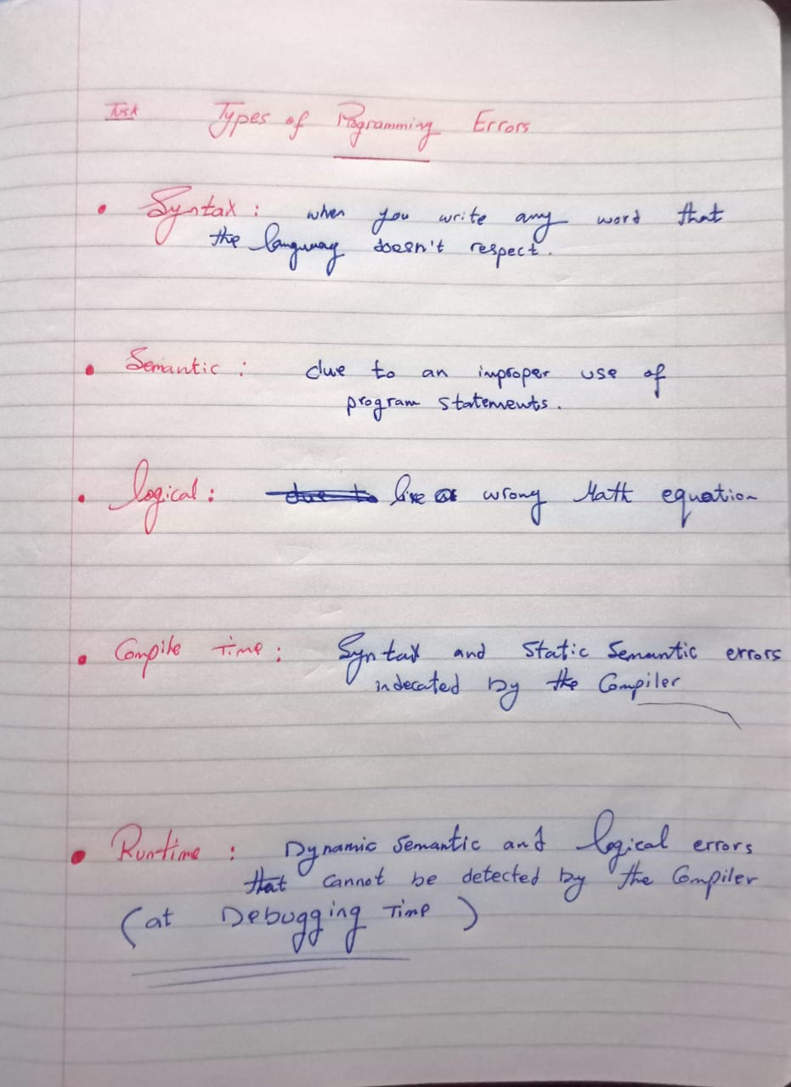

1. **PHP Is Programming or Scripting Language**

PHP is scripting language

1. **Examples for Interpreter Languages**
2. Python
3. JavaScript
4. Ruby
5. Perl
6. Lua
7. Tcl
8. PHP
9. R
10. Swift
11. MATLAB
12. Lisp
13. Prolog
14. BASIC
15. AWK
16. **Types of the way to write code and the best way**

????????